Name:

Databases Exploration Activity
Search:
Go to the LMC website. Click on Databases from School.
Choose World History in Context.
- Click Reference above the search box.
- Type in a topic of interest and click Search Reference.

Sample Results:
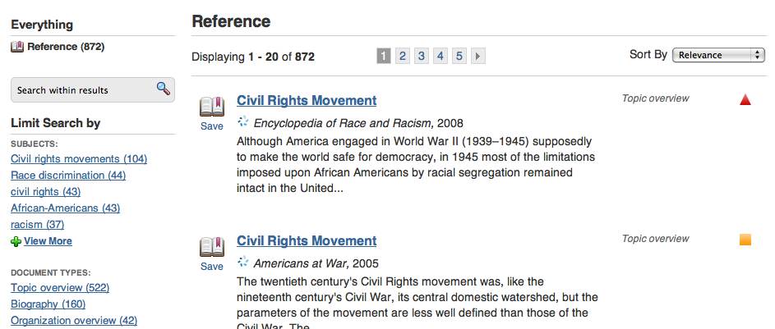
- Scan the results and the Limit Search by panel on the left for related topics.
- List two related topics below.
Topic | Related Topic | Related Topic

- Choose the Topic Overview link from the Document Type menu, to choose an article that provides a general overview of your topic.

Read:
- Read your Topic Overview article.
- In the table provided, list a few Key Figures, Events, and Terms.

Your Topic: _________________________________________________________

Key Figures | Key Events | Key Terms

Copy and paste the source citation here:

Search for a Primary Source related to your topic
Copy and paste the citation here:

Search for an image related to your topic
Copy and paste the citation here:

Search another Database:
Click World History: Ancient and Medieval (ABC-CLIO)
Search for your topic – Select an article
Copy and paste the citation here:

Cite:
Create a bibliography that includes all of the sources you have cited. Use the bibliography rubric below to guide you. Create your Bibliography below the rubric.
Bibliography Rubric
Teachers will assign point values | Expert | Apprentice | Novice | Rookie
SOURCES
- Sources selected are both credible and relevant | All sources are credible and relevant | 1 source is not credible or relevant | 2 sources are not credible or relevant | 3 or more sources are not credible or relevant
- Requirements for number and types of sources are met | All requirements are met | 1 requirement is not met | 2 requirements are not met | 3 or more requirements are not met
PAGE FORMAT
- Bibliography is on a separate page  - Title, “Bibliography,” is centered at the top  - Font is consistent throughout the page (preferably 12-pt.Times New Roman)  - Citations are in alphabetical order by the first main word of each entry (excluding ‘A’, ‘An’, or ‘The’)  - There is double spacing between citations  - There is single spacing within each citation  - After the first line of each citation, all additional lines are indented 5 spaces (“hanging indent”) | All formatting elements are correct | 1 formatting element is not correct | 2 formatting elements are not correct | 3 or more formatting elements are not correct
CITATION FORMAT (MLA 7)
- Each citation includes all required elements  - Elements within each citation are in the required order  - All dates are properly formatted  - Italics and quotation marks are used properly for titles  - Proper capitalization is used in each citation  - Proper punctuation is used in each citation | All citation elements are consistently correct | 1 citation element is not consistently correct | 2 citation elements are not consistently correct | 3 or more citation elements are not consistently correct
Total points earned

Bibliography

Save:
Save this Document to the Global Studies 10 Folder on the P Drive.

